Louisiana Tech University
Graduate Application Information

Go to gradapplication.latech.edu
Create a New Account (If you already have an account, select ‘Log In’ and use your full email address and password to login.)
Select ‘New Applicant’
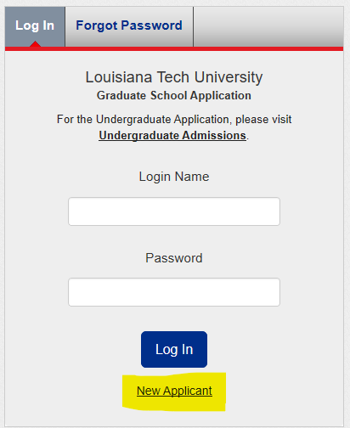
Use an email address that you regularly check.
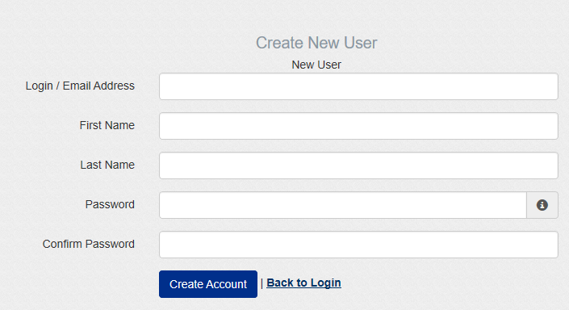
You will be sent an email with a link so that you can activate your account.

Now you may login using your full email address (login name) and password.
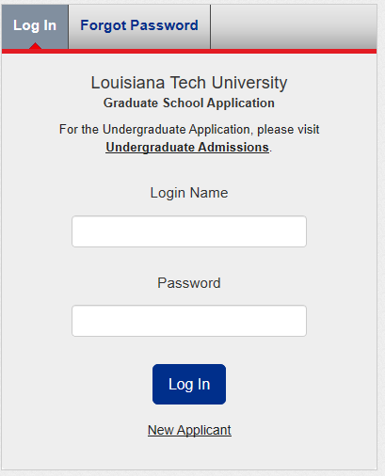
On the ‘Home’ tab, you will find instructions on selecting the admission type, term, and, college. Read these carefully as many applicants select the incorrect admission type and have to create an entirely new application.
The ‘Program Selection’ tab is where you will create a new application or view your started/submitted applications.
Choosing one of the four buttons below will begin a new application.
Once you have selected your application type, college, site, degree, major, term, and citizenship, then you may select ‘Apply’. (some programs require you to select a concentration)
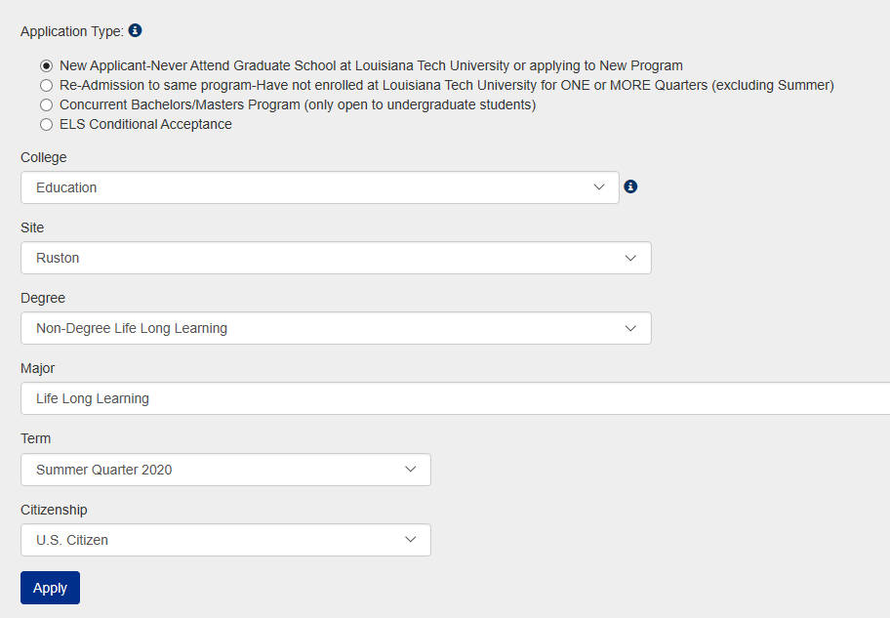
Once you select ‘Apply’, your application shows up in two places: a tab at the top of the page and a link in the ‘Program Selection’ tab.
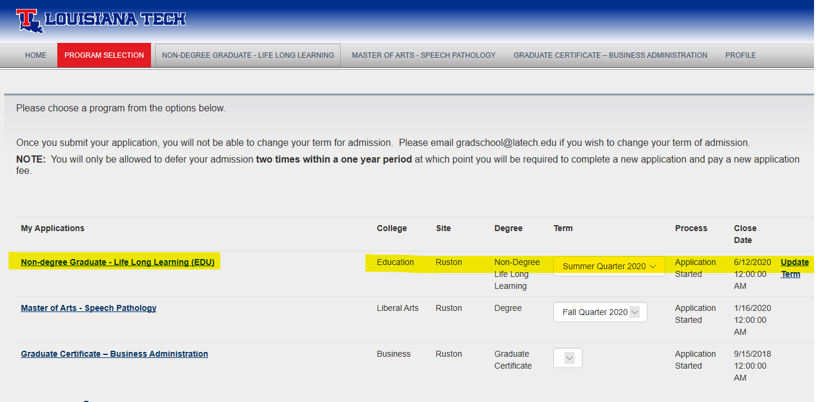
Click on either the tab or the link to access your application.
Once you are in the application, you will see a list of pages that must be completed in order to submit your application.
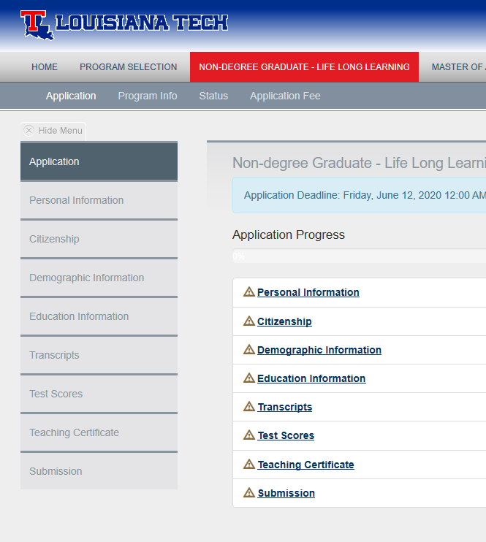
A completed page will show a green check. You will be able to submit your application once all pages are complete.
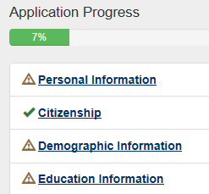
The $40 application fee can be paid within the application by clicking on the ‘Application Fee’ tab at the top of the page.

If you have any questions regarding the application process, please contact the Graduate School at gradschool@latech.edu or by phone at 318-257-2924. In the College of Education, you may reach out to Mrs. Debbie Lee to help with registration after you have been enrolled into grad school at dlee@latech.edu or 318-257-3229.

